ЛАБОРАТОРНА РОБОТА №4

ТЕМА: ФІГУРИ В WPF

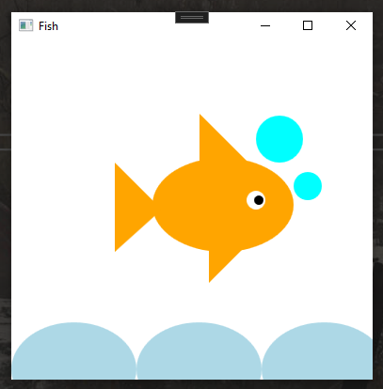

| <Window x:Class="WpfApp3.MainWindow"  xmlns="http://schemas.microsoft.com/winfx/2006/xaml/presentation"  xmlns:x="http://schemas.microsoft.com/winfx/2006/xaml"  xmlns:d="http://schemas.microsoft.com/expression/blend/2008"  xmlns:mc="http://schemas.openxmlformats.org/markup-compatibility/2006"  xmlns:local="clr-namespace:WpfApp3"  mc:Ignorable="d"  Title="Fish" Height="400" Width="400">  <Canvas>  <!-- Пол -->  <Ellipse Width="133" Height="100" Fill="LightBlue" Canvas.Left="0" Canvas.Top="300"/>  <Ellipse Width="133" Height="100" Fill="LightBlue" Canvas.Left="133" Canvas.Top="300"/>  <Ellipse Width="133" Height="100" Fill="LightBlue" Canvas.Left="266" Canvas.Top="300"/>  <!-- Рыба -->  <Ellipse Width="150" Height="100" Fill="Orange" Canvas.Left="150" Canvas.Top="125"/>  <!-- Хвост -->  <Polygon Fill="Orange" Points="0,0 50,50 0,95" Canvas.Left="110" Canvas.Top="130"/>  <!-- Плавник -->  <Polygon Fill="Orange" Points="0,0 35,0 0,35" Canvas.Left="210" Canvas.Top="223"/>  <Polygon Fill="Orange" Points="0,0 50,50 0,50" Canvas.Left="200" Canvas.Top="78"/>  <!-- Глаза -->  <Ellipse Width="20" Height="20" Fill="White" Canvas.Left="250" Canvas.Top="160"/>  <Ellipse Width="10" Height="10" Fill="Black" Canvas.Left="258" Canvas.Top="165"/>  <!-- Пузырьки -->  <Ellipse Width="30" Height="30" Fill="Aqua" Canvas.Left="300" Canvas.Top="140"/>  <Ellipse Width="50" Height="50" Fill="Aqua" Canvas.Left="260" Canvas.Top="80"/>  </Canvas>  </Window> |
| --- |